**Recycle Process of Lithium-Ion Battery: A Great Step Towards Safety**

Recycle, recover, and reprocess; this is what today's world is thinking with the advancement day by day. Recycling is a process where waste materials are reprocessed for use in new products. Basically, it is a process of recovering energy from waste. The materials' recyclability relies on their ability to retrieve the qualities that they had in their original condition. The main recycling steps include the collection, processing, or production of the waste materials into new goods and the purchase of such items which can then be recycled themselves. The requirement to extract, refine and process raw materials that cause severe air, soil, and water pollution is reduced by recycling. Recycling also minimizes the emissions of greenhouse gases which contribute to the fight against climate change. Recyclable materials include a large number of different types of glass, paper, cart, metal, plastic, tire, cloth, battery, and electronics. The recycling of biodegradable waste, for example, food or garden waste, or other recycling.

**About Lithium-Ion Battery**

A type of advanced rechargeable battery that uses lithium ions as the main component of its mechanism. Lithium-ion batteries are frequently utilized for portable gadgets and electric cars and are rising in popularity for military and aerospace applications. The anode ionizes and separates lithium atoms from their electrons during a discharge cycle.

|  |  |
| --- | --- |
| **Cell Voltage** | 3.6 / 3.7 / 3.8 / 3.85 V, LiFePO4 3.2 V |
| **Energy Density** | 250–693 W·h/L (0.90–2.43 MJ/L) |
| **Charge/Discharge Efficiency** | 80–90% |
| **Specific Energy** | 100–265 W·h/kg (0.36–0.875 MJ/kg) |
| **Consumer Price** | 6.4 Wh/US$ |
| **Specific Power** | ~250 – ~340 W/kg |
| **Self Discharge Rate** | 0.35% to 2.5% per month |

**Recycle Process of Lithium-Ion Battery**

Research on the recycling of lithium waste batteries is now mostly focused on the recycling of cobalt and lithium, which are high-value anode. Copper is a key raw element utilized in the construction of the negative electrode of lithium waste batteries. Based on the structural features of lithium batteries, an effective separation and recovery technique of waste lithium batteries is implemented in an ecologically friendly manner.

The recycling facility for lithium batteries is used to dismantle and reuse the mobile phone, cell phone battery, shell battery, cylindrical, etc. Various lithium battery types have different methods of recycling. Finally, we get graphite powder, cobalt acid lithium, aluminum, and copper.

Now, here on, we are going to discuss the whole process of recycling lithium-ion batteries using a flow chart.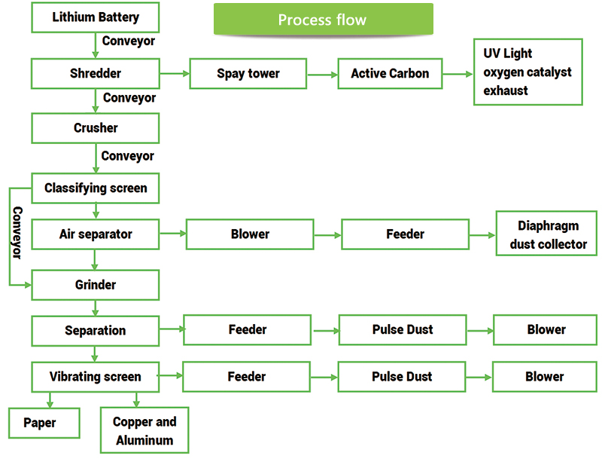

**Full Description:**

Recycling begins with batteries being sorted into chemicals. Collection centers deposit plumes in specified drums, sacks or boxes, acid, nickel-cadmium, nickel-metal-hydrides, and lithium-ion. Battery recyclers say that recycling may be profitably achieved by making accessible a consistent stream of chemically separated batteries.

The process of recycling starts by removing a gas-fired Thermal Oxidizer for flammable materials such as plastics and insulation. The polluting particles produced by the combustion process are removed before discharge into the atmosphere by the plant scrubber. This leaves metal content in clean and bare cells.

Then cells are cut into tiny parts and heated to the liquefied metal. Non-metallic materials are burnt off and the slag arm is removed from a black slag on top. These alloys settle by weight and, while still in a liquid state, are smeared like raw milk cream.

The cadmium vaporizes at a comparatively mild temperature. A fan propels the cadmium vapor into a huge pipe, which is refreshed with a water nebula during a process that seems like a pot of boiling water. The fumes condense to yield 99.95% pure cadmium.

Some recyclers do not segregate metals from one another but instead pour liquid metals into what is known as "pigs" in the industry. Others employ battery recyclers. The shipment of pigs and nuggets is made at metal recovery factories where nickel, chrome, and iron are produced in stainless steel and other high-end goods. Some recyclers use a liquid solution or freezes batteries of lithium with liquid nitrogen to reduce the possibility of a reactive event during crushing; however, it remains an issue to mix Li-ion starting batteries with the common plumacide model as the charged Li-ion is far more explosive than plumacide.

The energy-intensive recycling of the battery. Reports show that recovering metals from a few old batteries requires 6 to 10 times more energy than mining. The exception is the battery of lead-acid, from which plum may be simply drained and reused without complex processing. In some ways, if NiMH is accessible in big amounts, nickel can also potentially be recovered inexpensively.

A new method of recycling, known as chemical recycling, is created which recovers the metals by electrolysis. The procedure is reportedly more cost-efficient and delivers larger returns than conventional smelting with lower emissions. Aqua Metals has found one alternative to recycling lead-acid batteries. This technique can revolutionize traditional techniques of melting. An electrochemical method separates the pipe by breaking metals into nanoscopic particles that are scattered via water to form a hydro-colloidal metal. AquaRefining is the procedure. At present, technical problems hinder complete implementation.

In each nation, there are restrictions for the recycling of a new battery, and taxes are added to the purchase price. There are weight-invoiced recycling operations in North America and chemical rates are varying. While NiMH returns with nickel rather good, soft cadmium costs reduce used NiCd battery demand. Due to its low metal recovery, Li-ion charges a higher recycling price than most other types of batteries.

Li-ion battery recycling is not yet profitable and must be funded by the government. An incentive exists to recover expensive cobalt. There is currently no recycling technique capable of creating pure lithium in batteries for second use. Battery lithium mined; lithium second hand used for lubricants, glass, ceramics, and other uses Lithium is mined. It costs about $1,000 to $2,000 to recycle a ton of batteries; Europe is hoping to get a price of $300 for one ton. Ideally, transport would be included, but movement and handling of items should triple the total cost. To facilitate shipping, at important geographical places, Europe is putting up multiple smaller processing factories. This is partly because of the Basel Convention, which restricts the export of all except expended batteries of plumic acid. With the number of batteries wasted, new technologies are being attempted, without the help of organizations and governments, to make recycling economical.

**Technical Standards:**

|  |  |
| --- | --- |
| **Recovery Rate of Aluminium** | >98% |
| **Recovery Rate of Powder** | >98% |
| **Content of Powder in Aluminium** | <2% |
| **Success Rate** | 99% |
| **Failure rate** | <1% |
| **CMR** | ≥1.67 |
| **Others** | Contain dust collector |

**Working Performance:**

|  |  |
| --- | --- |
| **Raw Materials** | Lithium Battery |
| **Final Product** | Copper, Aluminium, Graphite Powder, Lithium Cobalt Oxide |

**Why Recycling is Important?**

As batteries degrade, their chemicals leak into groundwater and pollute surface water. Fires from garbage that can smolder for many years can result from lithium batteries. This has a bad effect on our airborne hazardous substances and contributes to global warming. Nonetheless, electricity is needed for world power-consuming items and batteries are frequently the only realistic choice. 

Lithium has now been compared to its rivals as the safest and most environmentally friendly alternative. But still, there are many consequences.

Unwanted MP3 and laptops commonly wind up in sites where electrode metals and electrolyte ionic fluids seep into the environment. Since lithium cathodes decay over time, no fresh batteries can be put in. The most environmental consequences were discovered in batteries that employ nickel and cobalt cathode (both uncommon) and solvent-based electrode manufacturing. These include loss of resources, world warming, environmental toxicity, and the effect on human health. That’s why we need to recycle these materials as early as possible in proper steps.